Faye Van Roekel

December 8, 2019

WEB-420 Assignment 8.4

Register - Request

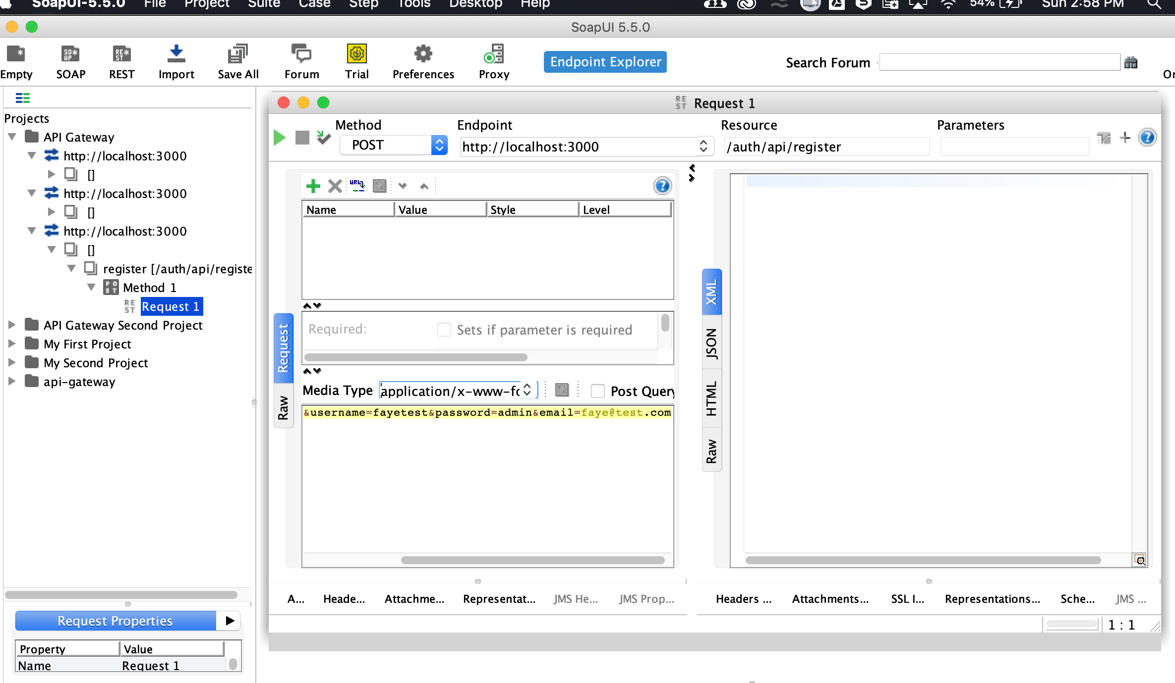

Register - Response

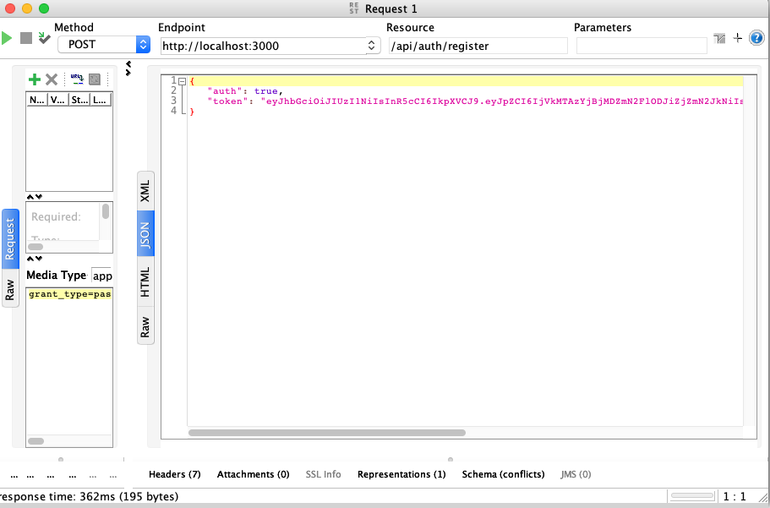

Token - Request

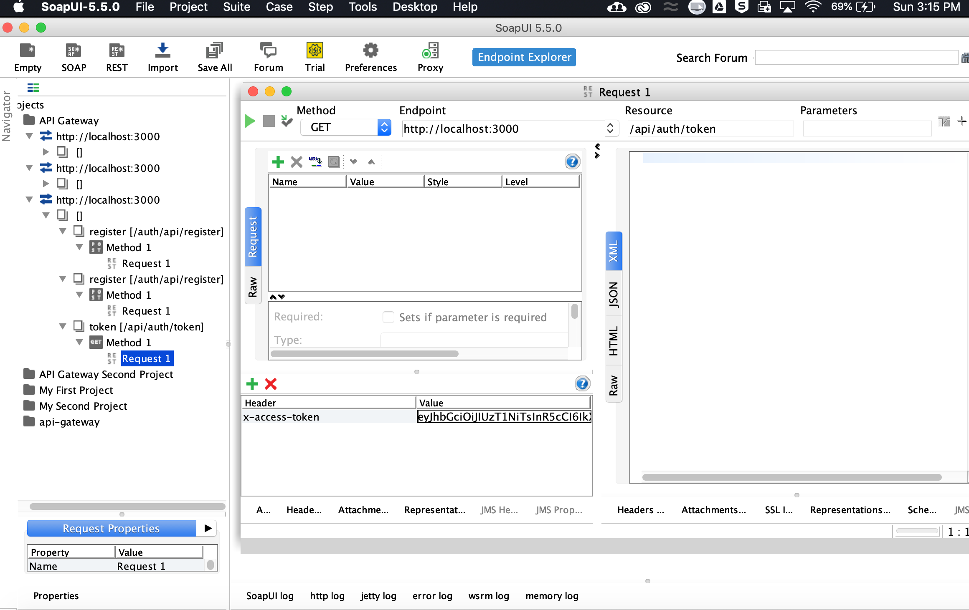

Token - Response

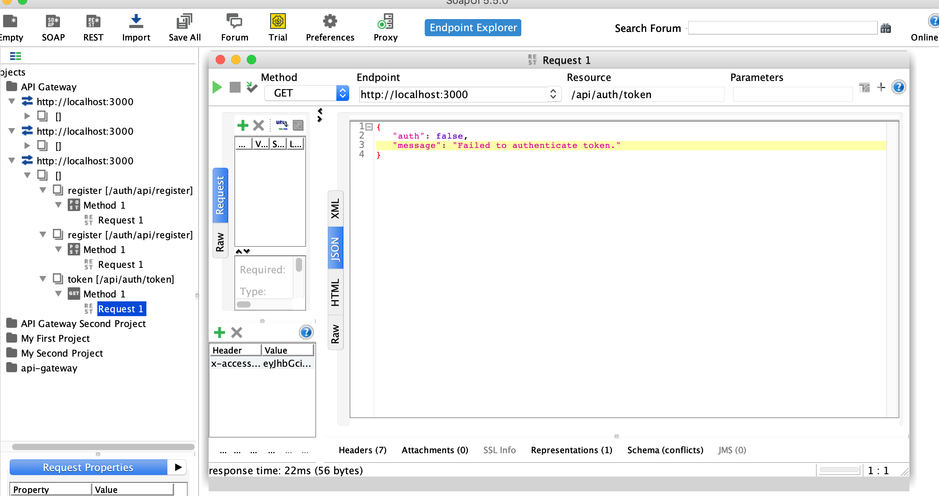

Login - Request

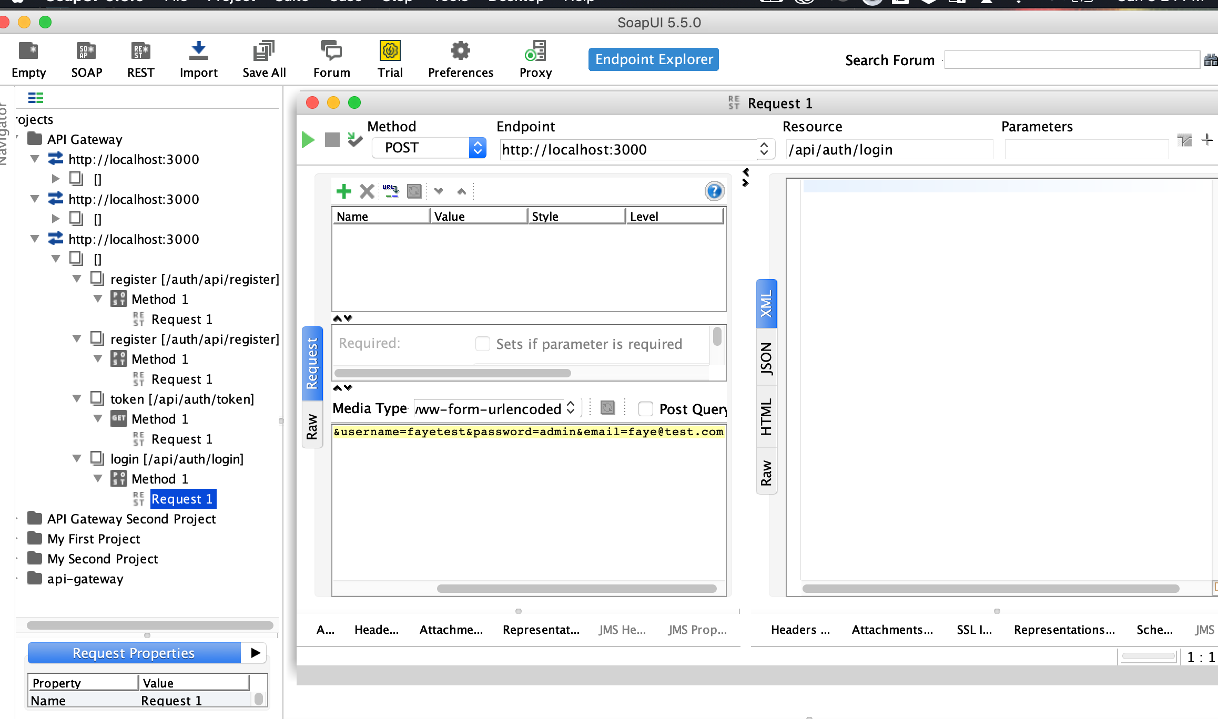

Login - Response

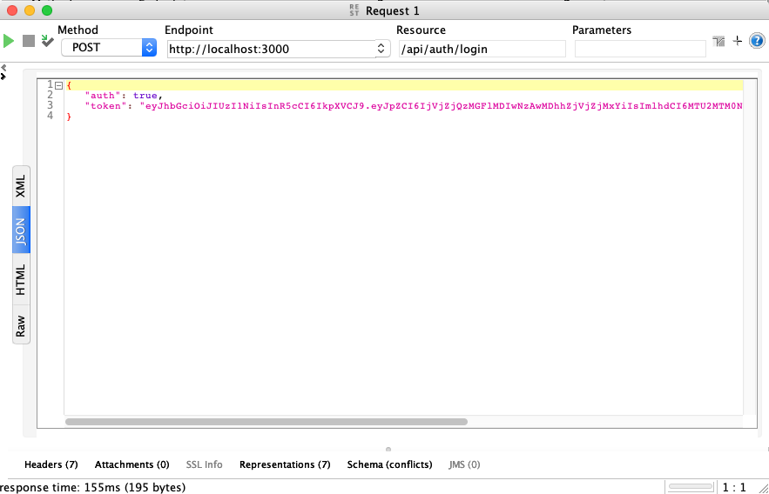

Logout - Request

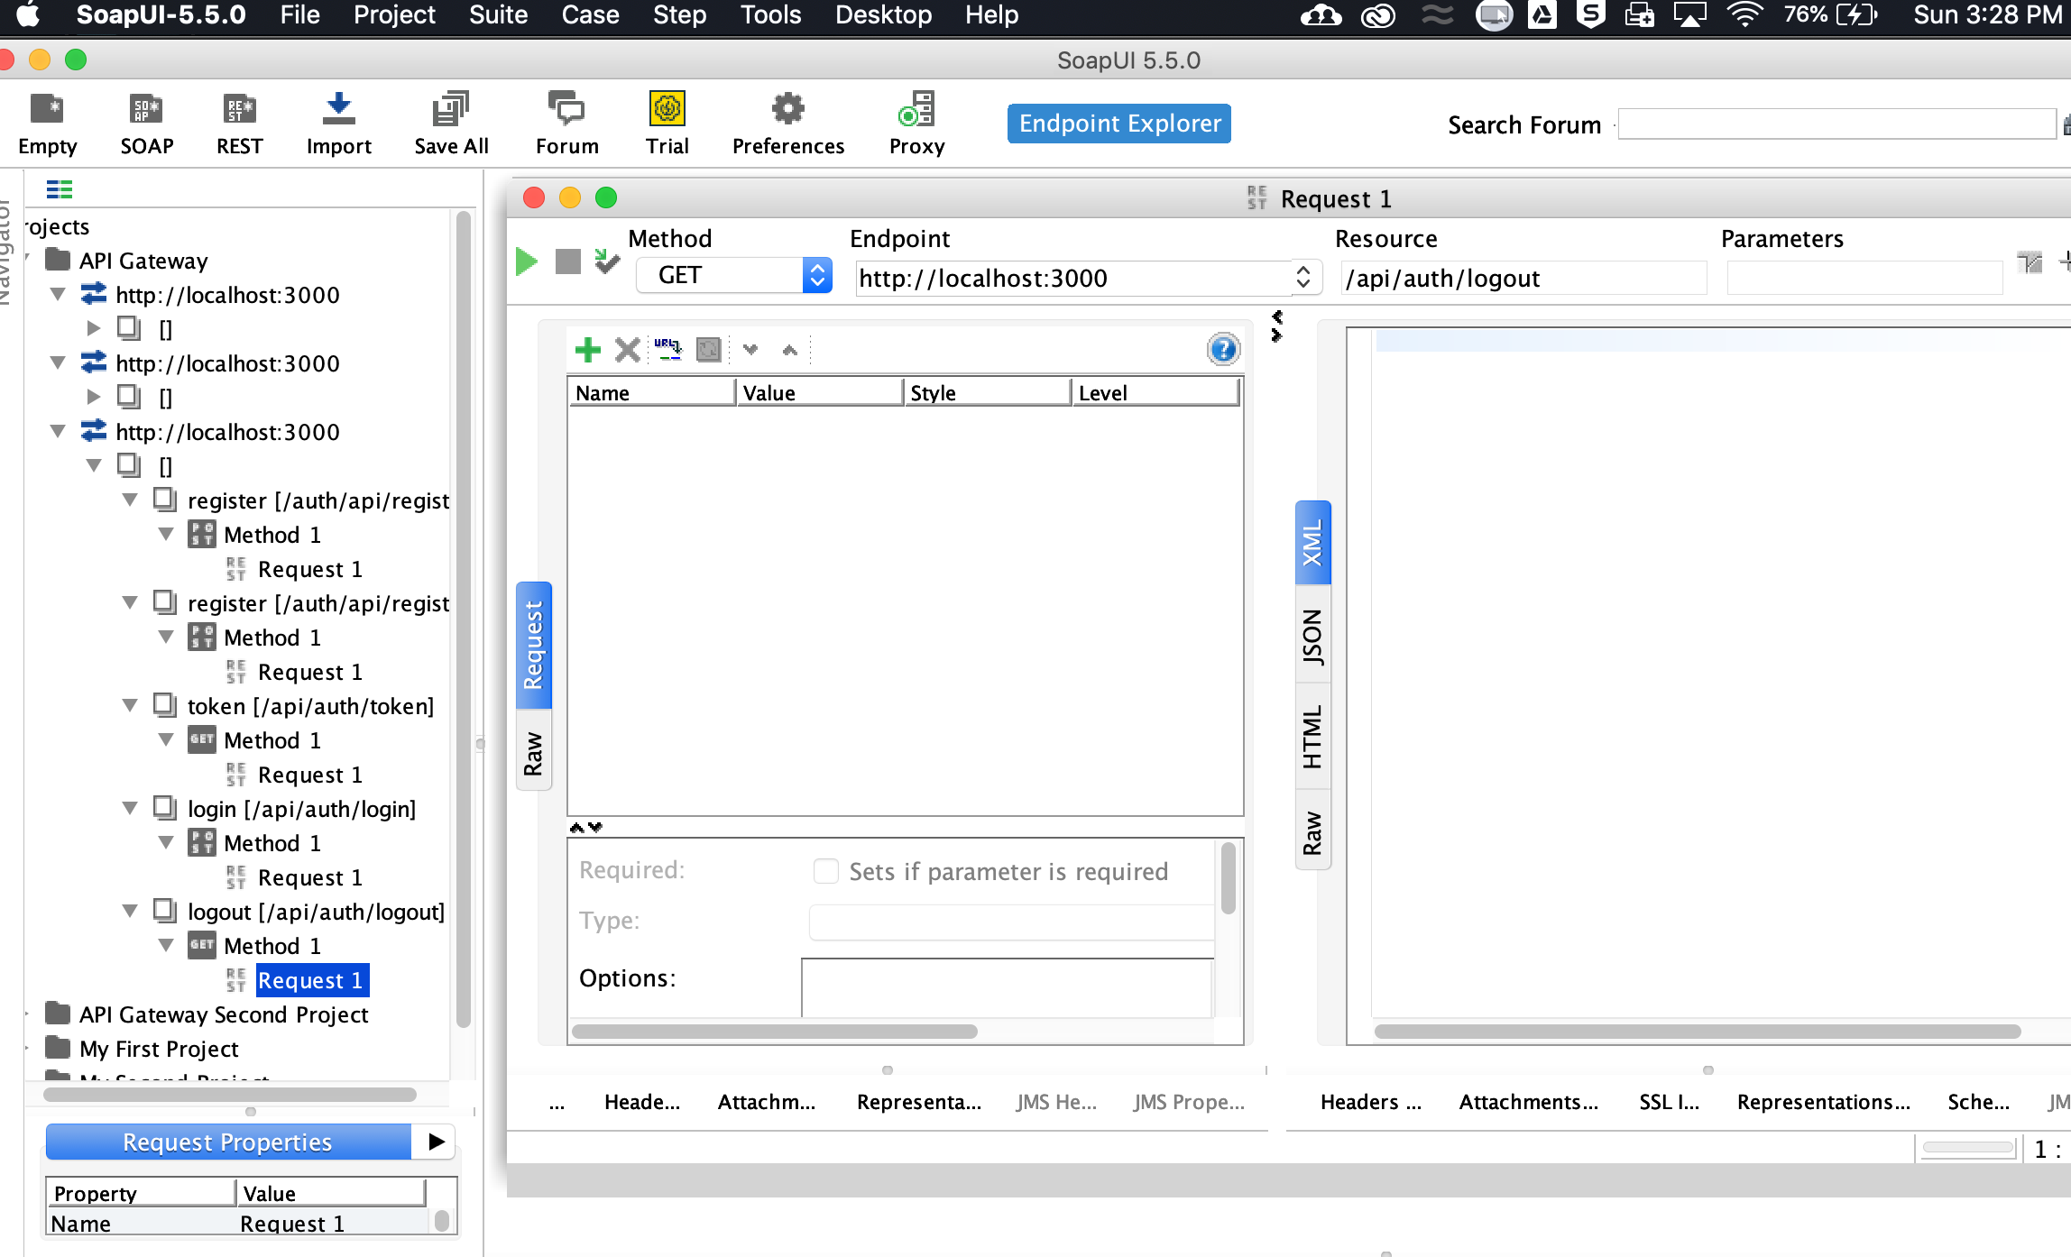

Response

Build and Test pics:

